Implement SSH, firewall, automation, and SELinux on a Linux server.Task: Submit a comprehensive report on server security configurations.
Tasks
1.Enable and configure SSH on your Linux server so that only key-based authentication is allowed and password authentication is disabled.

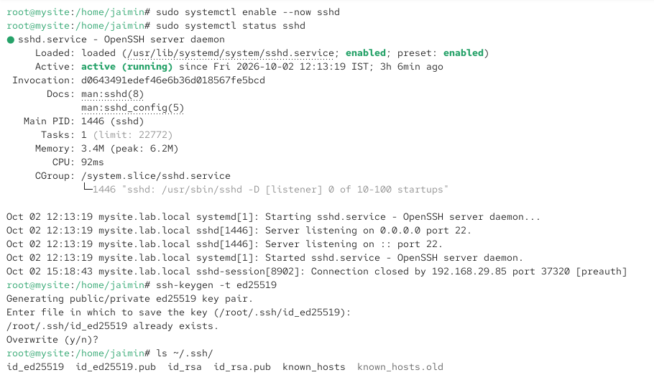
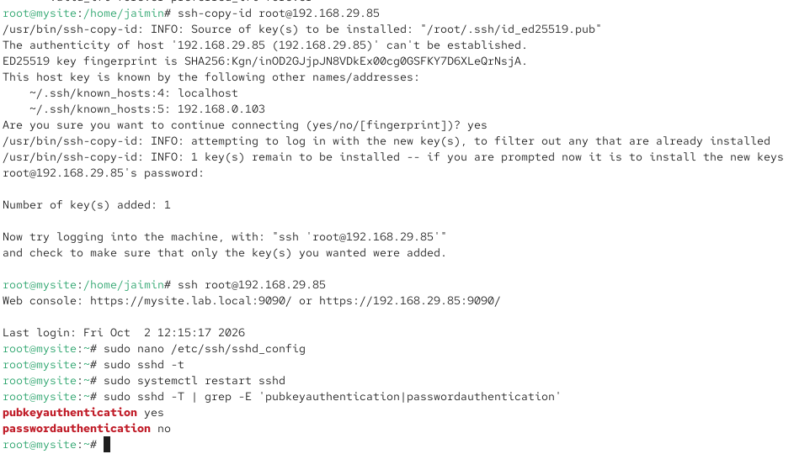
2.Set up a basic firewall using UFW or firewalld to allow only SSH (port 22) and HTTP (port 80) traffic, and block all other incoming connections.Hint: After applying rules, use a port scanning tool like nmap from another machine to verify only the allowed ports are open.

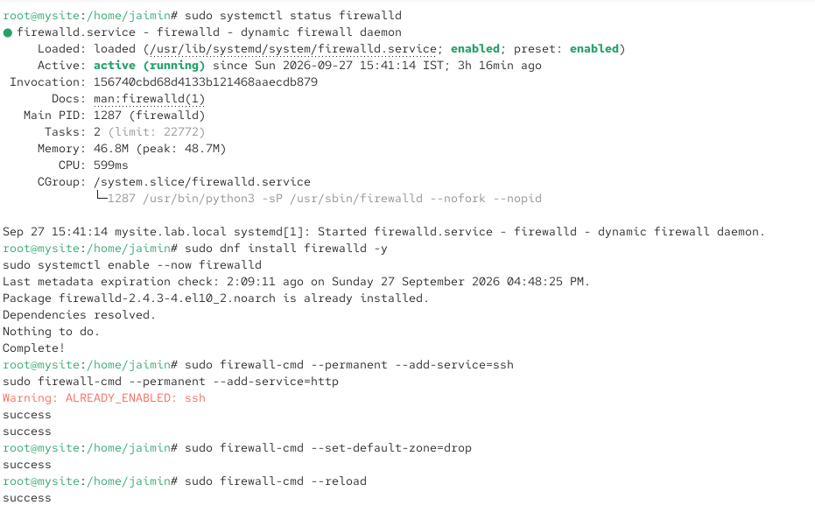
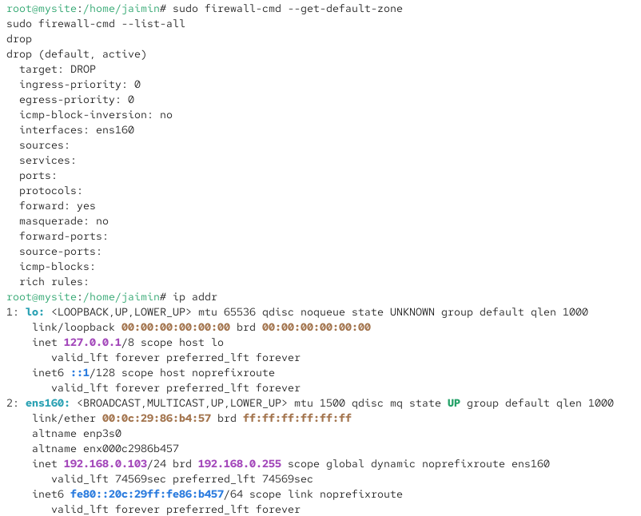
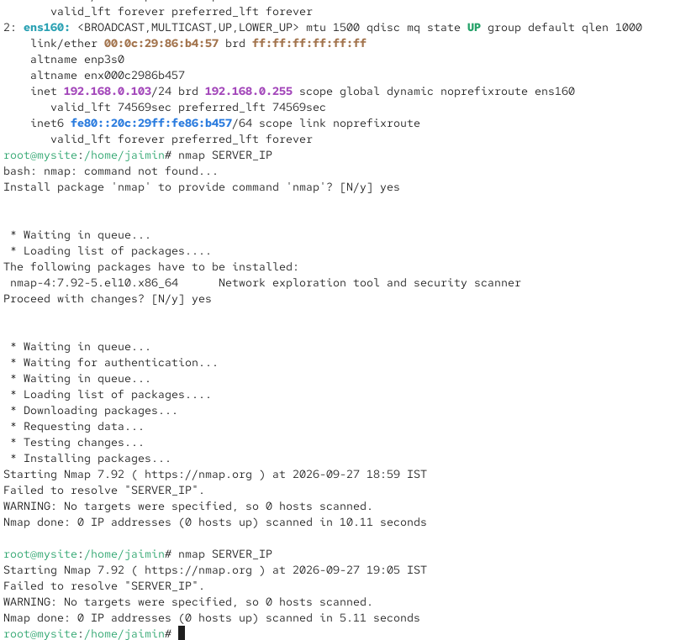
3.Write a shell script automate_backup.sh that creates a backup of your /home directory and saves it with a timestamp in /backups.

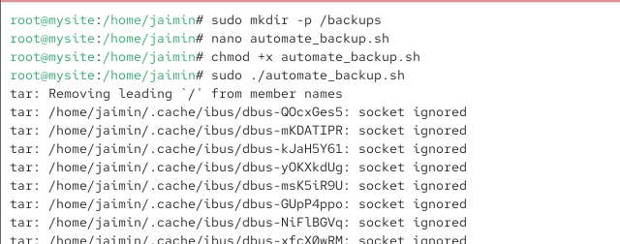
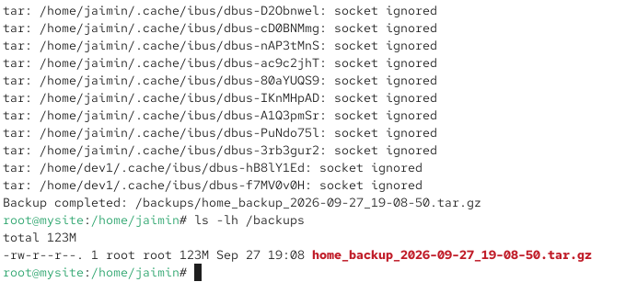
4.Check the current status of SELinux on your server, switch it to enforcing mode if it is not already, and verify the change using appropriate commands.Hint: Use the commands getenforce and setenforce.

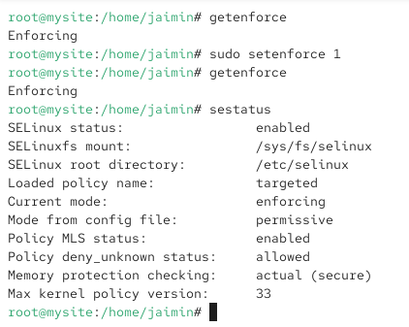
5.Use ChatGPT or Copilot to generate a checklist of at least 5 best practices for securing a Linux server, and compare it with your own server configuration to identify any missing steps.

Security Best Practice | My Server Status | Missing / Action
1. Use SSH key-based authentication | ✅Configured | Password login disabled
2. Disable SSH password authentication | ✅Configured | PasswordAuthentication no
3. Configure a firewall | ✅Configured | UFW/firewalld rules configured
4. Keep SELinux enabled | ✅Configured | SELinux policy is active
5. Keep the Linux system updated | ⚠️ Partially | Regular updates should be scheduled
6. Use strong passwords | ⚠️ Needs checking | Use strong, unique passwords
7. Disable unnecessary services | ⚠️ Needs checking | Review running services
8. Monitor system and security logs | ⚠️ Missing | Set up regular log monitoring

